Pre-Immersion - Introduction to Leadership I
Module One – Defining Leadership
SLO 1
Evaluate the characteristics and qualities of effective leadership based on basic principles of leadership
- I can define leadership based on basic principles of leadership.
- I can describe the characteristics and qualities of a good leader.
- I can evaluate my personal leadership characters and qualities.
Key Understandings
▪ In order for teams/groups to be effective, some form of leadership is needed.
▪ Effective leaders have particular characteristics and skills.

Activity One: Defining Leaderhsip
- What is leadership and why do we need leaders? Develop a group definition to present to the class.

- What individual characteristics define effective leaders? Think of a leader that you can identify in your own life. What characteristics do they possess? Share with your group.

- As a group, complete the “Elements of a Leader” activity. Try to find one characteristic, quality or attribute for each element. For example, the first symbol is H, which could stand for “honesty”. Element #33 is As which could be a leadership element of “always sensitive”.

- Alternately, your group can identify 20 key characteristics of an effective leader.

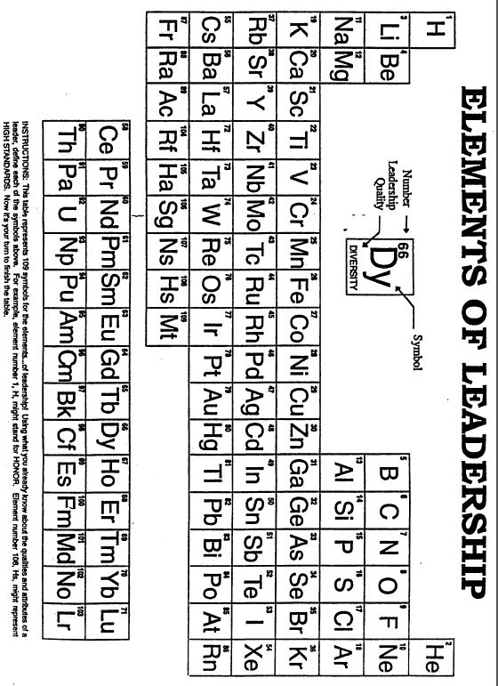
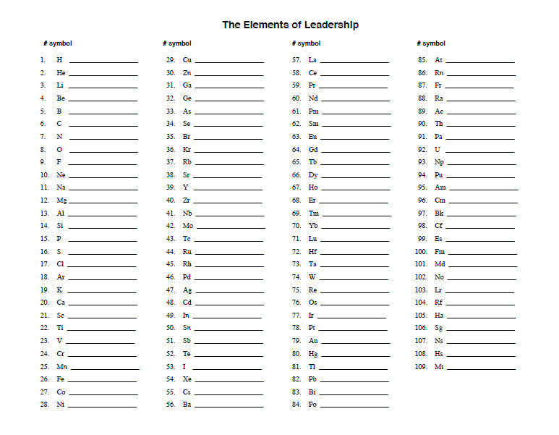
Summative Assessment: What is Leadership? What are the Characteristics of Effective Leaders?

Option One Leadership Interview Assignment

1. Select a school, family, or community leader to interview. This person should be someone that is respected and viewed as an effective and/or exemplary leader in an organization. Approve your leader with your teacher prior to moving to the next step.

2. Contact the leader and determine a date and time for the interview. This should be an in-person or phone interview but not an e-mail interview. It is important for there to be dialogue between both parties rather than sending a list of questions through e-mail.

3. Look at the list of questions provided and create three of your own questions you would like answered. Questions should be open-ended (require more than a one word answer) and relate to the Five Practices of Exemplary Leadership, specifically enable others to act.

4. Conduct the interview and take notes. Be sure to include the date, time, and location of the interview.

5. Write a one-page reflection on what you learned from your leadership interview. This should not be a repeat of the question/answers asked in the interview, but an overview of what you learned and how you can use this information in your own leadership experiences. Be prepared to share your interview and reflection in class.
Interview Questions:

- What does leadership mean to you?
- What strengths do you believe you have as a leader? Weaknesses?
- What has been your greatest influence as a leader?
- Leaders make other people feel strong and confident. What do you do to help others feel this way?
- Do you feel it’s important to delegate? If so, why? When is a good time to delegate?
- What are three or four actions you believe are essential to enable others to be successful?
- What advice do you have for building relationships and trust in an organization?
- Insert your questions here:

Option Two – Personal Written Reflection
- What does leadership mean to you?
- What strengths do you believe you have as a leader? Weaknesses?
- What has been your greatest influence as a leader?
- Leaders make other people feel strong and confident. What do you do to help others feel this way?
- Do you feel it’s important to delegate? If so, why? When is a good time to delegate?
- What are three or four actions you believe are essential to enable others to be successful?
- What advice do you have for building relationships and trust in an organization?

Option Three
Create a poem, story, visual or a video that explains one or more characteristic of an effective leader.

Option Four
Research a movie that is known for having a “Leadership Theme”.
Watch the movie and then write a one page summary that explains a minimum of three leadership lessons within the movie.

Option Five
Famous Leader Research
Research a famous leader. Identify their major accomplishments and which personal characteristics they had that enabled them to be successful in their task.

Assessment
5 | 4 | 3 | 2 | 1
Thoughtful, extensive and thorough. You demonstrate an understanding of the complexity of the concept. | Well thought out. You demonstrate a sound understanding of the concept. | Basic yet accurate. You demonstrate a good understanding of the concept. | General and brief. Your understanding of the concept lacks clarity. | Inadequate and brief.

Module Two – Leadership Styles
SLO 1
Evaluate the characteristics and qualities of effective leadership based on basic principles of leadership
- I can identify the traits of five leadership styles.
- I can evaluate my personal leadership characters and qualities.
SLO 3.3
Demonstrate fundamental leadership behaviours and skills while participating in a specific leadership team.
- I can communicate effectively, practice good interpersonal and personal management skills and empower my team members.
Key Understandings:
- Leaders demonstrate recognizable styles that may vary, based on circumstances.
- A leader generally demonstrates a dominant style. An effective leader will recognize when particular circumstances require a different style, and adjust accordingly.
- Leaders play certain roles and perform certain functions on teams.
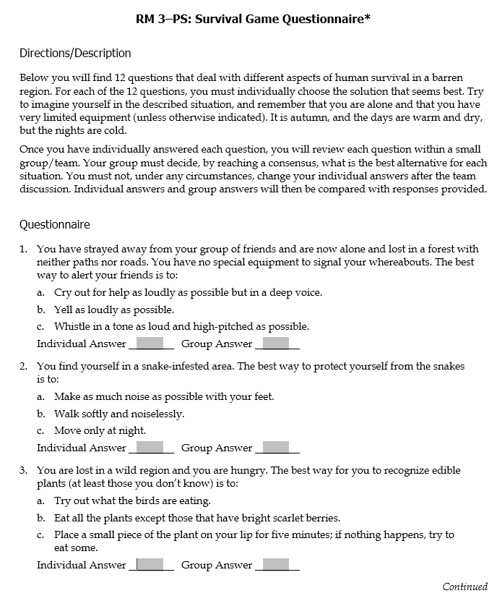
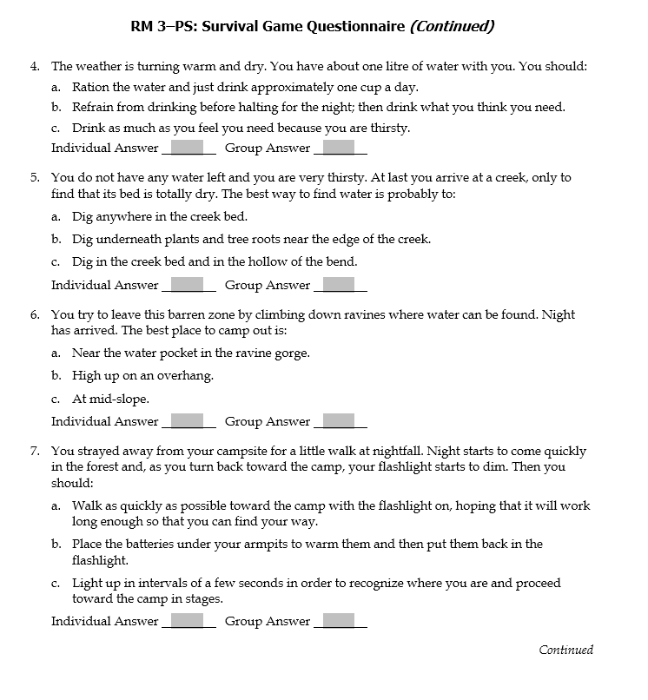

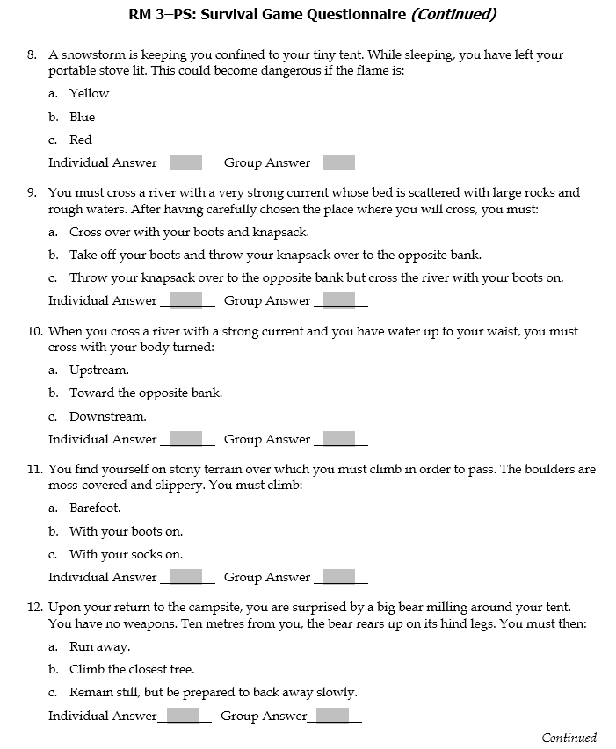
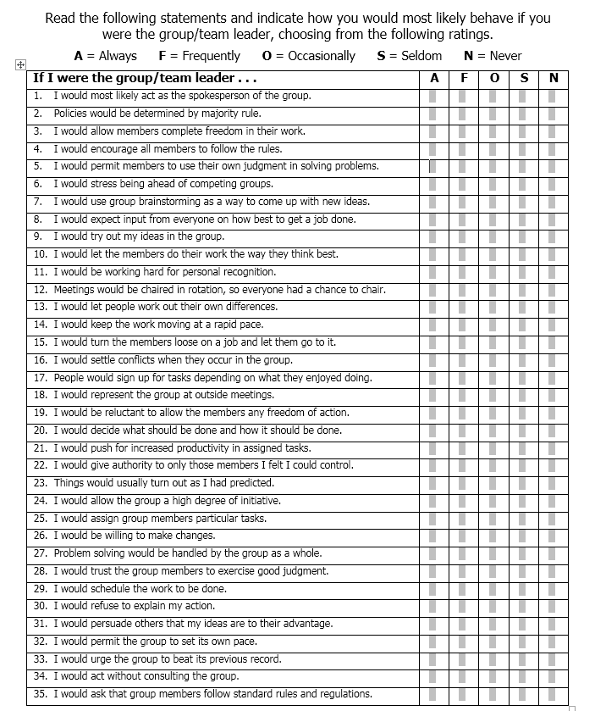
FIVE LEADERSHIP STYLES – Complete this chart.
Module Two – Summary Assignment Leadership Styles – Complete the Chart.
Leadership Style | Research/Definition | Where might this leadership style be very effective? Why? | Where might this leadership style be very ineffective? Why? | Have you seen this leadership style in action?  Discuss.
Democratic

laissez-faire

Transformative

Inclusive

Authoritarian

Think about how Leaders Emerge in a Group:
▪Qualified: Some people become leaders because they achieve the necessary
certification or credentials for a position. They may otherwise meet established criteria
or prerequisites that persons in authority over them associate with the leadership
position. Examples: lifeguard, teacher
▪Merited: Some people become leaders primarily through faithful and enthusiastic
participation and competent performance over time. These leaders may be considered
to have “paid their dues.” Examples: Olympic flag bearer, captain of a high school football team
▪Captured: Some people become leaders by campaigning for a position, being
“political,” or otherwise manoeuvring themselves into a position. Leaders in this
category may also take possession or seize the position through positive or negative
means. Examples: school principals, city mayor, dictator
Identified: Some people become leaders because they possess personal or professional
qualities that are recognized as beneficial and undeniable, and are appropriate for
meeting the team’s needs at a particular time. Examples: project manager of a business, military general
▪Defaulted: Some people become leaders simply because other team members are
unwilling or unable to accept the position or responsibility. Example: someone in a small discussion group needs to lead the discussion

Survival Scenario Reflection
Having learned about the five major leadership styles, think about how you responded to the group Survival task. What was your role? What did you do? How did you feel about your role and the group process?

What leadership roles are present in team situations?

Did you see any of the five leadership styles emerge? Were they effective? Explain.

Module Two Assessment
5 | 4 | 3 | 2 | 1
Thoughtful, extensive and thorough. You demonstrate an understanding of the complexity of the concept. | Well thought out. You demonstrate a sound understanding of the concept. | Basic yet accurate. You demonstrate a good understanding of the concept. | General and brief. Your understanding of the concept lacks clarity. | Inadequate and brief.

