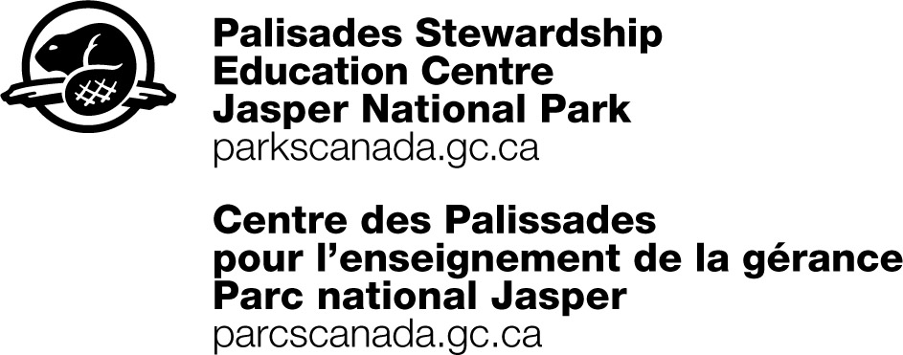

OUTDOOR SURVIVAL SKILLS – WILD1130

Day One –
Time | Activity | Location | Staff
6:00 pm | Arrival (before or after dinner)  Gear to Rooms  Basic Site orientation by PSEC staff  Site Orientation - gear sign out, start up briefing, set the tone Icebreaker: i.e. Cells  Orientation Hunt | Palisades
8:00 pm | Fire - Basic orientation (PSEC to orient group to fire pit, tools, extinguishing options) and handoff to teachers | Fire Pit | Teachers

Day Two – Thursday, April 14
Time | Activity | Location | Staff
8:00 am | Breakfast | Bunkhouse | Teachers
8:30 – 9:30 | Teambuilding Activities | Grounds
9:30 – 10:10  10:15 – 11:00 | Rotate (40 minutes each + 5 mins switch time)  - Tents and Bivy (modern tents, bivi sac, etc. Pros and cons of each type)  - Cooking (different stoves/fuels, make a drink or mix and fry bannock) May not have time to mix ingredients, perhaps just dry and wet prepped beforehand | Grounds  Grounds
11:00 am | Break
11:15-11:50  11:55-12:30 | Rotate (35 minutes each + transition)  - Fire  - Tools | Fire pit near Bullpen  Fire pit near Garage
12:30-1:15 | Lunch and packing for trip | Bunkhouse | teachers
1:15-1:45 | Trip Planning – Gathering Information  - Why is Valley of the 5 Lakes a reasonable destination?  - How long will it take us?  - What obstacles might we encounter? | Garage
2:00- 5:00 | Hike Valley of the Five Lakes  - PCA and Leave no Trace Focus  - Fire in fire pit? Trip Planning for this..?  - Map and compass skills practice | Valley of 5 Lakes
 | Reflection about the hike. If done early, poss. do some of the evening activities: Nightline, etc. | Grounds/Garage | S
6 pm | Dinner | Bunk-house | Teachers
6:45 – 7:45 | Large Group Presentation:  Food (1.4) and Food drying and prep.  Hygiene (1.5)  Gear (1.1)  10 essentials | Grounds/  Garage
7:45-8:00 | Ice breaker/Group Game | Grounds/  Garage
8:00-8:30 | Trip Planning – Maligne Lk Snowshoe | Garage
8:30 | Hand over to teachers:  Capture the Flag, Fire | Fire pit | Teachers

Day Three – Friday, April 15
Time | Activity | Location | Staff
8:00 am | Breakfast and check out of rooms, pack for day, pack bus, get bag lunch | Bunkhouse | Teachers
8:50 | Gear from Midden: winter boots, clothing, etc. | Midden
9:00 | Depart for Mary Schaeffer Trail Maligne Lk  (50min drive 1 way) | Mary Schaeffer Loop
10:00 -1:00 | Snowshoeing  Bag Lunch  - Shelter Building  - Cold Injuries (Emergency Situations)  - How to deal with an emergency in the field  - Animal encounters  - Games  - Reflection | Mary Schaeffer Loop
1:00- 1:15 | Closing Circle  What was your most memorable experience in JNP? | Parking Lot at Maligne Lake
1:15 | Departure for home | Parking Lot at Maligne Lake

